S-100 – Part 4a

Metadata

Page intentionally left blank

Contents

4a-1 Scope 1
4a-2 Conformance 1
4a-2.1 Conformance of this Profile with other Standards 1
4a-3 Conformance to this Profile 2
4a-4 Normative References 2
4a-4.1 Profile definition 2
4a-5 Requirements 3
4a-5.1 Business purpose and Intended use 3
4a-5.2 Metadata for describing geographic data and other resources 4
4a-5.3 Obligations/conditions 5
4a-5.4 Minimum metadata requirements 5
4a-5.5 Core metadata for geographic datasets 9
4a-5.6 Variations and preferences 10
4a-5.6.1 Metadata element fileIdentifier 10
4a-5.6.2 Metadata element parentIdentifier 11
4a-5.6.3 Geographic extent of the dataset 11
4a-5.6.4 Data and Date Time information 11
4a-5.6.5 Metadata extension information 12
Appendix 4a-A Metadata Entity Set Information 13
Appendix 4a-B Data Dictionary 15
Appendix 4a-C Metadata Implementation 16
Appendix 4a-D Discovery Metadata for Information Exchange Catalogues 17

Page intentionally left blank

Scope
The S-100 metadata profile described in parts 4a, 4b and 4c provides a specification for describing, validating and exchanging metadata about geographic datasets commonly produced by hydrographic organizations. Its purpose is the creation of metadata records that provide information about the identification, spatial and temporal extent, quality, application schema, spatial reference system, and distribution of digital geographic data. It is applicable to the cataloguing of datasets, clearinghouse activities, and the full description of geographic and non-geographic resources. Although it is primarily intended to describe digital geographic data, it may also be used to describe other resources such as charts, maps, images, textual documents and non-geographic resources. It makes provision for the description of; attributes, attributeTypes, features, featureTypes, collectionHardware, collectionSession, datasets, dataset series, nonGeographicDatasets, propertyTypes, fieldSession, software and services. It should be noted that this profile is not limited to the resources listed in the ISO 19115 codelist MD_ScopeCode <<Codelist>> (ISO 19115 - B.5.25), and can be extended to include additional resources if required.
This profile is based on ISO 19115:2003 Metadata and 19115 Part 2 - Metadata for imagery and gridded data. It also takes account of ISO/TS 19139 Metadata – XML schema implementation.
ISO 19115 provides an abstract structure for describing digital geographic information by defining metadata elements and establishing a common set of metadata terminology, definitions, and extension procedures. ISO/TS 19139 provides an eXtensible Markup Language (XML) implementation of ISO 19115, and guidance for developing profiles and extensions. It should be noted that this profile is not limited to the resources listed in the ISO 19115 codelist MD_ScopeCode <<Codelist>> (ISO 19115 - B.5.25), and can be extended to include additional resources if required.
This document is intended for developers and implementers of metadata applications, and provides a basic understanding of the principles and the overall requirements for standardisation of geographic information. It should be used in conjunction with the standards listed under clause 4a-4 – Normative references.
Further information concerning S-100 metadata implementation, encoding and quality principles are included in the following associated documents:
- S-100 Part 4b – Metadata Extensions for Imagery and gridded data;
- S-100 Part 4c – Metadata Quality Principles;
- Appendix 4a–C - Metadata Implementation.

Conformance

Conformance of this Profile with other Standards
In addition to the elements listed in ISO 19115:2005, this profile also adopts all associated 19115 obligations and conditions, with the exception of the metadataIdentifier element which has been changed from optional to mandatory. This has been done to facilitate the implementation and management of metadata records by allowing instances of duplicate metadata records to be identified, and defining the relationship of a child metadata record with its parent metadata record. The specifics of any metadata hierarchy relationships will be detailed in the product specifications.
Taking into account the change identified above, and the requirements documented in ISO 19106:2004, this Profile meets the requirements of conformance class 1. The Profile is a subset of ISO 19115:2005 and includes an extension in the context permitted by the base standard.
This profile includes parentMetadata as a core metadata element for geographic datasets. If a dataset metadata record has a parent metadata record, then this element becomes mandatory and therefore should be considered a ‘core’ element. Guidance on the XML implementation of this profile is included at Appendix 4a-C.

Backward compatibility
According to ISO 19115-1:2014, ISO plans to continue to make the UML models from ISO 19115:2003/Cor 1:2006 available. Backward compatibility is to be provided using a transformation service.

Conformance to this Profile
Any metadata claiming conformance to this Profile shall:
- Have content according to the data dictionary definitions in Annex B of ISO 19115:2005, (including changes required by ISO 19115:2003/Cor.1:2006) with the exception of the metadata element metadataIdentifier which has a mandatory obligation;
- Prove conformance by validating XML document instances against the S-100 Metadata Profile schemas which are available from the IHO website at Profiles based on this Profile.
All product specific implementations of this profile shall provide an Extensible Stylesheet Language (XSL) transform file/resource that can translate the XML document instances into the S-100 Metadata Profile XML format. These resulting XML document instances shall be validated using the ISO/TS 19139:2007 XSDs.

Normative references
The following referenced documents are required for the application of this document. For dated references, only the edition cited applies. For undated references, the latest edition of the referenced document (including amendments) applies.

Profile definition
The following documents were the references used to define the S-100 Metadata Profile:
ISO 19115:2005, Geographic information – Metadata.
ISO 19115:2003/Cor.1:2006, Geographic information - Metadata - Technical Corrigendum 1
ISO 19115-2:2006, Geographic information - Metadata - Part 2: Extensions for imagery and gridded data.
ISO 19119:2005, Geographic information – Services.
ISO/TS 19139:2007, Geographic information - Metadata - XML schema implementation.

Requirements

Business purpose and Intended use
Metadata can satisfy a number of uses:
- Data Discovery - summary descriptions of content and quality, contact details, off-line distribution and on-line references (URL) for on-line viewing.
- Data use - more extensive information on data coverage, maintenance, content and details of data creation. It includes additional contact, distribution and quality details.
- Data Fitness – additional detail about use, limitations, format, age, and extents. This level of metadata assists the user to determine the data’s suitability for use.
- Data Sharing – further detail relating to data content, transfer formats, and spatial representation.
- Data Management – the most detailed level of metadata, which includes information on the data quality regimes and data quality test results. This type of information is sometimes important when data is exchanged between organizations.

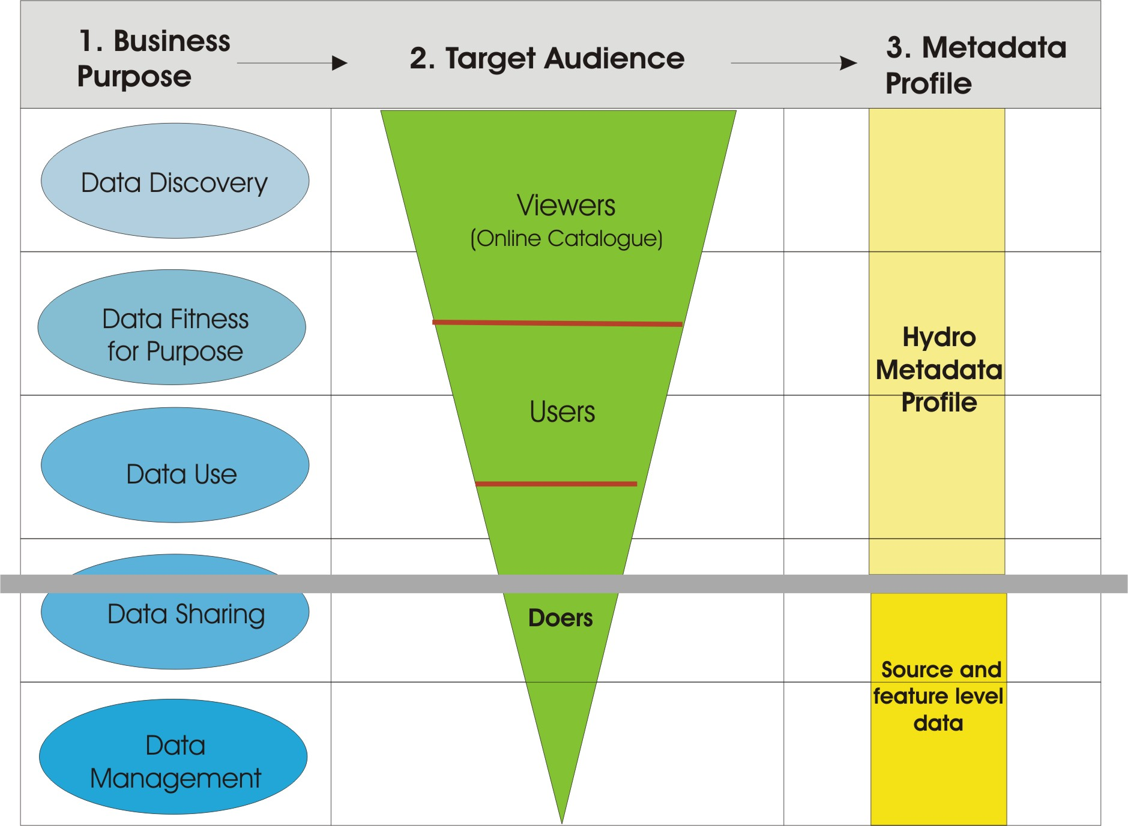
Figure 4a-1— Business Purpose
Figure 4a-1 above illustrates the relationship between the types of metadata required by different user communities, and the scope of this profile. Each S-100 based product specification will describe the source and feature-level metadata that will be required to support data use, data sharing, and data management. The more demanding requirements for comprehensive metadata (as illustrated by “Doers” in Figure 4a-1), require further attribution to allow source selection and feature analysis.
ISO 19115 does not provide all the metadata necessary to describe imagery. This has been included in part 2 to ISO 19115, which incorporates elements that are needed for the description of imagery and gridded data. ISO 19130 – “Sensor and data model for imagery and gridded data”, is an important standard associated with ISO 19115 Part 2, as it specifies the information required to support the geolocation of georeferenceable imagery, including a sensor description and associated physical information defined by a sensor model, fitting functions, and ground control points. It describes how the sensor measurements and the geolocation information are logically associated. In particular, ISO 19130 describes the sensor and data model for hydrographic sonar requirements, and the associated metadata. This will be described in relevant product specifications.
An XML implementation of the ISO 19115 which describes how the abstract UML models in ISO 19115 and 19115 Part 2 are converted into XML is documented in ISO publication ISO/TS 19139.
Although this profile is largely based on the above mentioned standards, reference to additional standards will need to be made. (See sections – “Normative References”).
This Profile defines:
- Mandatory and conditional metadata sections, metadata entities, and metadata elements;
- The minimum set of metadata elements for any resource in order to conform to this Profile;
- The core metadata for geographic datasets;
- Optional metadata elements that allow for a more extensive standard description of resources; and
- The option to extend the Profile to cater for specialised needs.
Implementation of the Profile is based on ISO/TS 19115-3:2016, and includes:
- The use of the ISO/TS 19115-3:2016 XSDs;
- XML documents containing dictionaries to implement the ISO 19115-1:2014 codelists (XML data dictionaries of the ISO 19115-1:2014 codelists in GML format); and
- XML data dictionaries of the S-100 Geographic Extent Names and Search Words.
While the UML class S100_Metadata specialises the class MD_Metadata, the specialisation only involves restrictions of the parent class. Hence, for the purpose of XML implementation, the MD_Metadata element shall be used to support interoperability with other ISO 19100 standards for geographic information. This follows the recommendation in ISO/TS 19139:2007 Annex A.4.

Metadata for describing geographic data and other resources
The Profile identifies the metadata required to describe digital geographic data and resources, and is applicable to independent datasets, dataset aggregations, geographic features, feature classes and attributes. Metadata is documented via the creation of XML document instances, which are validated against the S-100 Metadata Profile XSDs, and relevant codelists and enumerations.
Metadata records must contain a minimum set of core elements (see Section 4a-5.3 which are necessary for conformance with this Profile. A number of additional elements required for discovery purposes have also been identified and are described in the Appendix 4a-C.
Quality information is important for assessing whether datasets or resources are fit for use, and quality metadata have therefore been documented in part 4c.

Obligations/conditions
Obligation descriptors have been included to provide an indication of whether a metadata entity or element must be documented or may be conditionally or unconditionally left to the discretion of the metadata encoder. This descriptor may have the following values: M (mandatory), C (conditional) or O (optional). The following definitions form section B.1.5 Obligation/Condition of ISO 19115:2005 are included below.
A mandatory (M) obligation means the metadata class or metadata element shall be documented.
A conditional (C) obligation specifies an electronically manageable condition under which at least one metadata class or a metadata element is mandatory. ‘Conditional’ is used for one of the three following possibilities:
- Expressing a choice between two or more options. At least one option is mandatory and must be documented.
- Documenting a metadata class or a metadata element if another element has been documented.
- Documenting a metadata element if a specific value for another metadata element has been documented.
If the answer to the condition is positive, then the metadata entity or the metadata element shall be mandatory.
An optional (O) obligation means that the metadata class or the metadata element may be documented or may not be documented. Optional metadata classes and optional metadata elements have been defined to provide a guide to those looking to fully document their data. (Use of this common set of defined elements will help promote interoperability among geographic data users and producers world-wide.) If an optional class is not used, the elements contained within that class (including mandatory elements) will also not be used. Optional classes may have mandatory elements; those elements only become mandatory if the optional entity is used.

Minimum metadata requirements
The minimum requirements for recording metadata include a number of elements that must be completed in order to conform to this Profile. It should be noted that the obligation is not mandatory for all elements, however some conditional elements may become mandatory under certain conditions (for example resourceType).
Table 4a-1 identifies the minimum set of metadata elements that should be completed for datasets and other resources. These elements also form part of the minimum metadata for geographic datasets listed in Table 4a-2.
Table 4a-1 — Minimum metadata for geographic datasets and other resources
Name | Path | Datasets | Other resources
Metadata file identifier | MD_Metadata.metadataIdentifier > MD_Identifier.code | M | M
Metadata language | MD_Metadata.defaultLocale > PT_Locale.language | C  ( documented if not defined by the encoding process) | C  (same as for dataset)
Metadata character set | MD_Metadata.defaultLocale > PT_Locale.characterEncoding | C  (documented if ISO 10646-1, is not used and not defined by the encoding process) | C  (same as for dataset)
Metadata file parent identifier | MD_Metadata.parentMetadata > CI_Citation.identifier | C  (documented if the hierarchy of a higher level exists) | C  (same as for dataset)
Party responsible for the metadata information | MD_Metadata.contact > CI_Responsibility.CI_Individual (table 4a-2)  or  MD_Metadata.contact > CI_Responsibility.CI_Organization (table 4a-3) | M  (either organization or individual must be documented) | M  (same as for dataset)
Date(s) associated with the metadata | MD_Metadata.dateInfo > CI_Date | M  (creation date required, other dates may be provided) | M  (same as for dataset)
Resource title | MD_Metadata.identificationInfo > MD_DataIdentification.citation >CI_Citation.title | M | M  (See note 2)
Resource reference date | MD_Metadata.identificationInfo > MD_DataIdentification.citation > CI_Citation.date > CI_Date.date | M | M  (See note 2)
Resource reference date type | MD_Metadata.identificationInfo > MD_DataIdentification.citation > CI_Citation.date > CI_Date.dateType > CI_DateTypeCode | M | M  (See note 2)
Abstract describing the resource | MD_Metadata.identificationInfo > MD_DataIdentification.abstract | M | M  (See note 2)
Resource default language | MD_Metadata.identificationInfo > MD_DataIdentification.defaultLocale > PT_Locale.language | M | C  (only used if MD_DataIdentification has been used)
Resource default character set | MD_Metadata.identificationInfo > MD_DataIdentification.defaultLocale > PT_Local.characterEncoding | C  (documented if UTF-8 is not used) | C  (documented if UTF-8 is not used)
Topic category | MD_Metadata.identificationInfo > MD_DataIdentification.topicCategory | M | C  (if resourceType = ‘series’ topicCategory is mandatory)
Geographic location of the resource (by description) | MD_Metadata.identificationInfo > MD_DataIdentification.extent > EX_Extent > EX_GeographicDescription.geographicIdentifier > MD_Identifier.code | C  (See notes 3 and 4) | O  (See note 4)
West longitude | MD_Metadata.identificationInfo > MD_DataIdentification.extent > EX_Extent > EX_GeographicBoundingBox.westBoundLongitude | C  (See notes 3 and 4) | O  (See note 4)
East longitude | MD_Metadata.identificationInfo > MD_DataIdentification.extent > EX_Extent > EX_GeographicBoundingBox.eastBoundLongitude | C  (See notes 3 and 4) | O  (See note 4)
South latitude | MD_Metadata.identificationInfo > MD_DataIdentification.extent > EX_Extent > EX_GeographicBoundingBox.southBoundLatitude | C  (See notes 3 and 4) | O  (See note 4)
North latitude | MD_Metadata.identificationInfo > MD_DataIdentification.extent > EX_Extent > EX_GeographicBoundingBox.northBoundLatitude | C  (See notes 3 and 4) | O  (See note 4)
Name of the scope/type of resource for which the metadata is provided | MD_Metadata.metadataScope > MD_MetadataScope.resourceScope > MD_ScopeCode (codelist – ISO 19115-1) | M  (default = “dataset”) | M
Description of scope of resource for which the metadata is provided | MD_Metadata.metadataScope > MD_MetadataScope.name | O | O

NOTE1 ISO 10646-1 - Information technology — Universal Multiple-Octet Coded Character Set (UCS).
NOTE2 MD_ServiceIdentification may be used instead of MD_DataIdentification if hierarchyLevel = ‘service’.
NOTE3 For a geographic dataset, include metadata for the geographic bounding box (West longitude, East longitude, South latitude and North latitude) or the geographic description identifier (The use of geographic bounding box is recommended - see Section 5.6.3).
NOTE4 If any one of west longitude, east longitude, south latitude or north latitude exists, then the remaining three must also be completed.

Table 4a-2 — Individuals
Name | Path | Datasets | Other resources
Name of the individual | CI_Individual.name | C  (documented if ‘positionName’ not documented) | C  (same as for dataset)
Position of the individual in an organization | CI_Individual.positionName | C  (documented if ‘name’ not documented) | C  (same as for dataset)
Contact information for the individual | CI_Individual > contactInfo > CI_Contact | M  (see note 6) | M  (see note 6)

Table 4a-3 — Organisations
Name | Path | Datasets | Other resources
Name of the organisation | CI_Organisation.name | C  (documented if ‘positionName’ not documented – see Note 5) | C  (same as for dataset)
Position of an individual in the organisation | CI_Organisation.positionName | C  (documented if ‘name’ not documented – see Note 5) | C  (same as for dataset)
Contact information for the organisation | CI_Organisation.contactInfo > CI_Contact | M  (see note 6) | M  (see note 6)
An individual in the named organisation | CI_Organisation.individual > CI_Individual | M | M

Note 5 S-100 restricts ISO 19115-1 in that documenting the ‘logo’ attribute of CI_Organisation is not sufficient to allow omission of both ‘name’ and ‘positionName’.
Note 6 At least one of CI_Contact attributes phone / address / onlineResource / contactInstructions must be documented.

Core metadata for geographic datasets
Although ISO 19115:2005 defines an extensive set of metadata elements, only a subset of these are used. It is essential however that a minimum number of metadata elements be maintained for a dataset (as listed in Table 4a-1). When describing geographic datasets however, it is recommended that additional metadata elements (in addition to the minimum requirements for geographic datasets) be used. This set of metadata, which includes the minimum set of metadata and some additional optional elements, is referred to as recommended metadata. Table 4a-2 lists the recommended metadata required to describe a dataset, typically for catalogue purposes. This list contains metadata answering the following questions:
- ‘Does a dataset on a specific topic exist (“what”)?’
- ‘For a specific place (“where”)?’
- ‘For a specific date or period (“when”)?’
- ‘A point of contact to learn more about or order the dataset (“who”)?’
By using the core metadata described below, interoperability will be enhanced, and potential users should be able to understand without ambiguity the characteristics of geographic datasets or resources.
Table 4a-2 — Recommended metadata for geographic datasets
Name | Path | Obligation
Unique identifier for this metadata record | MD_Metadata.metadataIdentifier > MD_Identifier.code | M a
Metadata language | MD_Metadata.defaultLocale > PT_Locale.language | C b
Metadata character set | MD_Metadata.defaultLocale > PT_Locale.characterEncoding | C c
Metadata file parent identifier | MD_Metadata.parentMetadata > CI_Citation.identifier | C d
Party responsible for the metadata information | MD_Metadata.contact > CI_Responsibility.CI_Individual  or  MD_Metadata.contact > CI_Responsibility.CI_Organization | M
Date(s) associated with the metadata | MD_Metadata.dateInfo > CI_Date | M
Metadata standard name | MD_Metadata.metadataStandard > CI_Citation.title | O
Metadata standard version | MD_Metadata.metadataStandardVersion | O
Dataset title | MD_Metadata.identificationInfo > MD_DataIdentification.citation > CI_Citation.title | M
Dataset reference date | MD_Metadata.identificationInfo > MD_DataIdentification.citation > CI_Citation.date | M
Resource identifier | MD_Metadata.identificationInfo > MD_DataIdentification.citation > CI_Citation.identifier > MD_Identifier.code | O
Abstract describing the data | MD_Metadata.identificationInfo > MD_DataIdentification.abstract | M
Resource point of contact | MD_Metadata.identificationInfo > MD_DataIdentification.pointOfContact > CI_Responsibility | O
Spatial representation type | MD_Metadata.identificationInfo > MD_DataIdentification.spatialRepresentationType | O
Spatial resolution of the dataset | MD_Metadata.identificationInfo > MD_DataIdentification.spatialResolution > MD_Resolution.distance or MD_Resolution.equivalentScale or MD_resolution.vertical or MD_Resolution.angularDistance or MD_Resolution.levelOfDetail | O e
Dataset language | MD_Metadata.identificationInfo > MD_DataIdentification.language | M
Dataset character set | MD_Metadata.identificationInfo > MD_DataIdentification.defaultLocale > PT_Locale.characterEncoding | C f
Dataset topic category | MD_Metadata.identificationInfo > MD_Identification.topicCategory | M
Geographic location of the dataset (by four coordinates or by description) | MD_Metadata.identificationInfo > MD_Identification.extent > EX_Extent > EX_GeographicBoundingBox or EX_GeographicDescription | C g, h
Temporal extent information for the dataset | MD_Metadata.identificationInfo > MD_Identification.extent > EX_Extent.temporalElement | O
Vertical extent information for the dataset | MD_Metadata.identificationInfo > MD_DataIdentification.extent > EX_Extent.verticalElement > EX_VerticalExtent | O
Lineage | MD_Metadata.resourceLineage > LI_Lineage | O
Reference system | MD_Metadata.referenceSystemInfo > MD_ReferenceSystem.referenceSystemIdentifier > RS_Identifier | O
Distribution Format | MD_Metadata.distributionInfo > MD_Distribution > MD_Format | O
On-line link to resource | MD_Metadata.distributionInfo > MD_Distribution > MD_DigitalTransferOption.onLine > CI_OnlineResource | O
Constraints on resource access and use | MD_Metadata.identificationInfo > MD_DataIdentification > MD_Constraints.useLimitations and/or MD_LegalConstraints and/or MD_SecurityConstraints | O
Name of the scope/type of resource for which the metadata is provided | MD_Metadata.metadataScope > MD_MetadataScope.resourceScope | C i

- The Profile imposes a mandatory obligation on the metadata element fileIdentifier.
- Language: documented if not defined by the encoding process.
- characterEncoding: Documented if UTF-8 is not used and not defined by the encoding process.
- Documented if a higher level of hierarchy level exists (for example if the geographic ‘dataset’ is part of a ‘series’).
- Distance is preferred over equivalentScale because the scale will change when presented at different sizes on a screen. distance or equivalentScale must be documented if available.
- characterSet: Documented if ISO 10646-1 is not used.
- Include either the geographic bounding box (extents) or the geographic description (It is recommended that geographic bounding box should be used - see Section 5.6.3).
- If any one of west longitude, east longitude, south latitude or north latitude exists, then the remaining three must also be completed.
Source: Adapted from Table 3 - Core metadata for geographic datasets (ISO 19115:2005).

Variations and preferences

Metadata element metadataIdentifier
The obligation for the metadata element fileIdentifier is ‘optional’ in ISO 19115:2005, however this profile applies a more stringent obligation and defines an extension to make the obligation ‘mandatory’. Each product specification will provide rules for creating file identifiers.
For example, this could support linkage between parent and child metadata records. The identifier code of the child's parentmetadata/CI_Citation.identifier element is the same as the identifier code of the parent's metadataIdentifier element, thus supporting the hierarchical relationship between metadata records.

Metadata element parentIdentifier
The metadata element parentMetadata (conditional obligation) is included as a recommended metadata element for describing geographic datasets in the profile. Under certain conditions this metadata element is mandatory. For instance, in some cases dataset metadata may be part of a dataset series. In these circumstances parentMetadata shall be populated.
The concept of metadata scope allows a dataset to be described in more than one metadata record. A dataset may be part of a collection, and in this instance, the dataset may be described in two metadata records: as a dataset in its own right and as part of a collection. The dataset may also be more discrete. For example, a chart may be described individually and as part of a collection or (chart series). An organization may choose to produce a metadata record for each chart and a metadata record for the collection (chart series). Further information on metadata scope and their implementation is available in Annex D and Annex E of ISO 19115-1.

Geographic extent of the dataset
The ISO 19115:2005 condition for spatial extent determines that if the resourceType is ’dataset’ then either the geographic bounding box or the geographic description is mandatory. To make spatial searches more effective, it is recommended that the extent be described as a geographic bounding box in preference to a geographic description. Completing only the geographic description code may not satisfy the needs of spatial searches as an extent could be ambiguous (for example, ‘France’ could mean the mainland only or it may include all external territories). However, in other circumstances, the geographic descriptions are clearly defined, and can present a more efficient means of description. Therefore, product specifications shall specify how geographic extent of a dataset is described.

Data and Date Time information
Dates for both the metadata and the actual data must be provided. In MD_Metadata, there is a date stamp for the metadata. In the citation, provided as part of MD_Identification, there is a production, publication, or revision date for the dataset. These dates are not necessarily the same. In some cases, one set of metadata may be provided for multiple sets of data, which may have been produced, published or revised at different times. The need for an associated date of origin is not restricted to digital or geographic data. Users who derive results from reprocessed data need to know the version of the data they are using.
This profile constrains the choices available in ISO 19115, which references ISO 19103 and ISO 8601. These classes are documented in full in ISO/TS 19103. Both Date and DateTime, shall follow the basic format for complete specification, as per ISO 8601.
- Date: the date format shall be year, month and day and will be encoded as a character string (that is, CCYYMMDD).
- DateTime: shall be a combination of a date and a time (given by hour, minute and second), with a time zone, that is CCYYMMDDTHHMMSS±hhmm (or ‘Z’ for UTC). Note that +0100 implies one hour ahead of UTC, such as might occur in Geneva.
- Where any part of the date is not known then lower precision dates or dateTimes need to be stored as per ISO 8601, for example if a date was known to be sometime in 1990 but the exact month and day are not known then the date would be given as 1990.

Metadata extension information
The S100_Metadata class specialises the MD_Metadata class, restricting the obligation of metadataIdentifier from optional to mandatory. Tables 4a-3 and 4a-4 provide relevant information about the extension for S100_Metadata. A modified UML diagram is provided at Appendix 4a-A, the modified values for the data dictionary are provided at Appendix 4a-B (Table B-1 - Modifications to data dictionary ISO 19115:2005).
Table 4a-3 — Metadata extension for S100_Metadata
MD_MetadataExtensionInformation
MD_ExtendedElementInformation
name | S100_Metadata
definition | S-100 Metadata Profile of MD_Metadata
obligation | Mandatory
condition
dataType | specifiedClass
maximumOccurrence | 1
domainValue
parentEntity | MD_Metadata
rule | New class
Rationale | Extension of MD_Metadata to include change of obligation to fileIdentifier
Source | organisationName | International Hydrographic Organization
Source | role | owner
conceptName
code

Table 4a-4— Metadata extension for S100_Metadata
MD_MetadataExtensionInformation
MD_MetadataElementInformation
name | metadataIdentifier
definition | ISO 19115-1:2014 Table B.2
obligation | mandatory
condition
dataType | Class
maximumOccurrence | 1
domainValue | MD_Identifier
parentEntity | S100_Metadata
rule | Change obligation to mandatory
Rationale | To ensure a file identifier is always entered
Source | organisationName | International Hydrographic Organization
Source | role | owner
conceptName
code

Metadata for services
The elements to be used for discovery of services are listed in Table 4a-5. The elements are similar to those used for datasets except that SV_ServiceIdentification replaces MD_DataIdentification and two conditional elements are added to document the coupling (if any) between the service and a dataset.

This edition of the S-100 profile of metadata for services does not document the operations proffered by services. Accordingly the profile omits the optional metadata elements and attributes related to operation information that are defined in ISO 19115-1.
Table 4a-7 — Metadata for the discovery of services
Name | Path | Obligation
Unique identifier for this metadata record | MD_Metadata.metadataIdentifier > MD_Identifier.code | M a
Metadata language | MD_Metadata.defaultLocale > PT_Locale.language | C b
Metadata character set | MD_Metadata.defaultLocale > PT_Locale.characterEncoding | C c
Metadata parent identifier | MD_Metadata.parentMetadata > CI_Citation.identifier | C d
Party responsible for the metadata information | MD_Metadata.contact > CI_Responsibility.CI_Individual  or  MD_Metadata.contact > CI_Responsibility.CI_Organization | M
Date(s) associated with the metadata (creation date) | MD_Metadata.dateInfo > CI_Date | M
Metadata standard name | MD_Metadata.metadataStandard > CI_Citation.title | O
Metadata standard version | MD_Metadata.metadataStandard > CI_Citation.edition | O
Service title | MD_Metadata.identificationInfo > SV_ServiceIdentification.citation > CI_Citation.title | M
Date used to identify the service | MD_Metadata.identificationInfo > SV_ServiceIdentification.citation > CI_Citation.date | M
Resource identifier | MD_Metadata.identificationInfo > SV_ServiceIdentification.citation > CI_Citation.identifier > MD_Identifier | O
Resource abstract | MD_Metadata.identificationInfo > SV_ServiceIdentification.abstract | M
Responsible party | MD_Metadata.identificationInfo > SV_ServiceIdentification.pointOfContact > CI_Responsibility | O
Spatial representation type | MD_Metadata.identificationInfo > MD_DataIdentification.spatialRepresentationType | O
Spatial resolution of the dataset | MD_Metadata.identificationInfo > MD_Identification.spatialResolution > MD_Resolution.distance or MD_Resolution.equivalentScale or MD_resolution.vertical or MD_Resolution.angularDistance or MD_Resolution.levelOfDetail | O e
Dataset language | MD_Metadata.identificationInfo > MD_DataIdentification.defaultLocale > PT_Locale.language | M
Dataset character set | MD_Metadata.identificationInfo > MD_DataIdentification.defaultLocale > PT_Locale.characterEncoding | C f
Service topic category | MD_Metadata.identificationInfo > SV_ServiceIdentification.topicCategory | M
Geographic location of the service (by four coordinates or by description) | MD_Metadata.identificationInfo > SV_ServiceIdentification.extent > EX_Extent.geographicElement > EX_GeographicExtent > EX_GeographicBoundingBox or EX_GeographicDescription | C g, h
Temporal extent information for the service | MD_Metadata.identificationInfo > SV_ServiceIdentification.extent > EX_Extent.temporalElement | O
Vertical extent information for the dataset | MD_Metadata.identificationInfo > SV_ServiceIdentification.extent > EX_Extent.verticalElement > EX_VerticalExtent | O
Lineage | MD_Metadata.resourceLineage > LI_Lineage | O
Reference system | MD_Metadata.referenceSystemInfo > MD_ReferenceSystem.referenceSystemIdentifier > RS_Identifier | O
Distribution Format | MD_Metadata.distributionInfo > MD_Distribution > MD_Format | O
On-line link | MD_Metadata.identificationInfo > SV_ServiceIdentification.citation > CI_Citation.onlineResource > CI_OnlineResource | O
Constraints on resource access and use | MD_Metadata.identificationInfo > SV_ServiceIdentification > MD_Constraints.useLimitations and/or MD_LegalConstraints and/or MD_SecurityConstraints | O
Resource scope | MD_Metadata.metadataScope > MD_Scope.resourceScope | C i
Operated dataset | MD_Metadata > SV_ServiceIdentification.operatedDataset > CI_Citation | C j
Operates on | MD_Metadata > SV_ServiceIdentification.operatesOn > MD_Identifier | C j

- the Profile imposes a mandatory obligation on the metadata element fileIdentifier
- language: documented if not defined by the encoding process
- characterEncoding: documented if UTF-8, is not used and not defined by the encoding process
- documented if a higher level of hierarchy level exists (e.g. if the geographic ‘dataset’ is part of a ‘series’)
- distance is preferred over equivalentScale because the scale will change when presented at different sizes on a screen. distance or equivalentScale must be documented if available.
- characterSet: documented if UTF-8 is not used
- include either the geographic bounding box (extents) or the geographic description (It is recommended that geographic bounding box should be used - see Section 5.6.3)
- if any one of west longitude, east longitude, south latitude or north latitude exists, then the remaining three must also be completed
- Mandatory for resources that are not datasets
- Reference to the resource on which the service operates. For any one resource, either ‘operated dataset’ or ‘operates on’ is used (i.e., both must not be used for the same resource).

Appendix 4a-A
Metadata Schema Class Information
(normative)
The structure of metadata included in the S-100 Metadata Profile is defined with reference to UML diagrams that identify metadata packages and classes included at Annex A of ISO 19115:2005 (and further modified by Technical Corrigendum 1 ISO 19115:2003/Cor.1:2006). [It should be noted that in ISO 19115:2003/Cor.1:2006, there is a discrepancy between the use of “locale” in the UML diagram (Figure A.1) and element 11.2 “locate” in Table B.2.1. The word “locale” in MD_Metadata shown in Figure 4a-A-1 below is the correct reference.]
The new class S100_Metadata shows the relationship to MD_Metadata and its related metadata classes. For the purpose of this Profile Metadata entity set information replaces the equivalent diagram Figure A.1 in ISO 19115:2005.

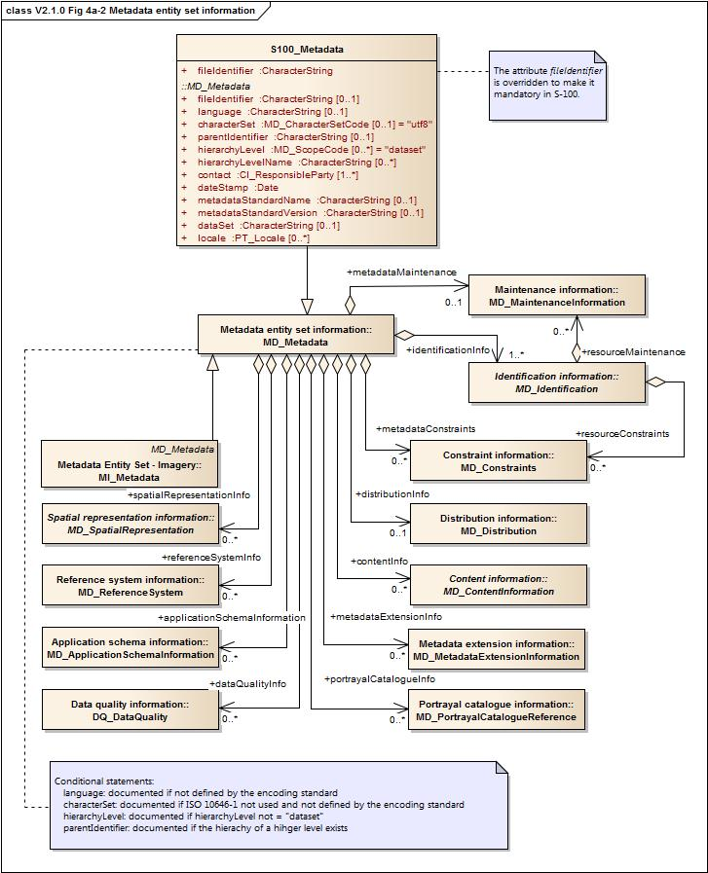
Source: Adapted from ISO 19115:2005 and ISO 19115:2003/Cor.1:2006
Figure 4a-A-1— Metadata schema classes
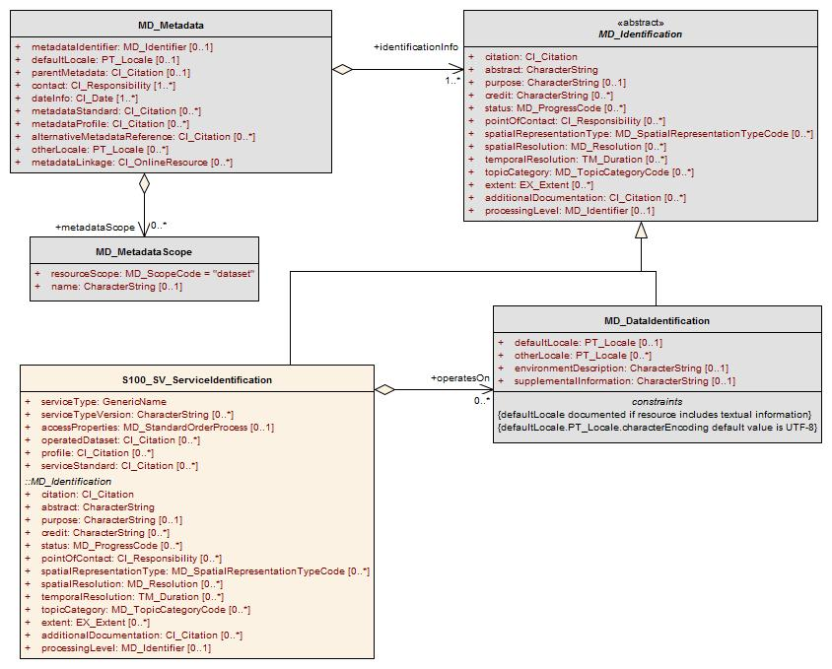
Source: Adapted from ISO 19115-1:2014
Figure 4a-A-2— Service metadata information classes

Appendix 4a-B
Data Dictionary
(normative)
The data dictionary in Annex B of ISO 19115:2005 (and further modified by ISO 19115:2003/Cor.1:2006) describes the characteristics of the metadata identified in the UML package diagrams included at Annex A of 19115.
Modifications to the data dictionary, required to recognise the extension to the metadata element fileIdentifier that was introduced in this Profile, are included at Table 4a-B-1. The information contained in the table replaces, or is in addition to, that provided at B.2.1, Annex B, ISO 19115:2005 and ISO 19115:2003/Cor.1:2006.
Table 4a-B-1 — Modifications to the data dictionary ISO 19115:2005
 | Name / Role name | Short Name | Definition | Ob | Max Occ | Data type | Comment
1 | MD_Metadata | Metadata | root entity which defines metadata about a resource or resources | M | 1 | Class | See B.2.1, Annex B, ISO 19115:2005
1.1 | S100_Metadata | S100Meta | root entity which defines metadata about a resource or resources | M | 1 | Class | Specialises MD_Metadata class
2 | fileIdentifier | mdFileID | unique identifier for this metadata file | M | 1 | CharacterString | Free text (changed obligation from optional to mandatory)
Ob = Obligation / Condition Max Occ = Maximum occurrence
Appendix 4a-C
Metadata Implementation
(normative)
Background
ISO 19115:2005 defines the content of a set of metadata elements, their definitions, data types and inherent dependencies. The logical model of the metadata specifies the content and not the form of implementation or the form of presentation. A primary goal in the management of metadata for resources is the ability to access the metadata and the related resource it describes. This requires software implementations using common encoding methods to achieve operational use of the metadata.
It is necessary to implement the Profile in order to prove compliance. ISO/TS 19139:2007 is an XML schema implementation of ISO 19115:2003 and can be used to prove partial compliance to ISO 19115:2003 and the S-100 metadata profile. IHO has developed additional Schematron rules to enforce the additional restriction for the fileIdentifier element. Proof of compliance to this profile be via validation of the XML document instances against the ISO/TS 19139:2007 XML Schema Definition (XSDs) and the S-100 Schematron Metadata Rules.
While the S100_Metadata class specializes the MD_Metadata class, the specialization only involves restricting fileIdentifier from optional to mandatory. Therefore the MD_Metadata root element must be used instead of the S100_Metadata for XML instances of S-100 metadata in order to ensure interoperability with ISO standards and software tool.
Granularity of geographic data supported: The notion of cataloguing a set of related documents together in a discoverable series is common practice for map catalogues. With digital spatial data, the definition of what constitutes a dataset is more problematic and reflects the institutional and software environments of the originating organisation. Common metadata can be derived for a series of related geographic datasets, and such metadata is generally relevant or can be inherited by each of the dataset instances. Software to support this inheritance of metadata for geographic data within a cataloguing system can simplify data entry, update and reporting.
There is a potential hierarchy of reusable metadata that can be employed in implementing a metadata collection. By creating several levels of abstraction, a linked hierarchy can assist in filtering or targeting user queries to the requested level of detail. The hierarchy should not necessarily be interpreted to require multiple copies of metadata being managed online. Conversely, the definition of general metadata can be supplemented by spatially specific metadata that, when queried, either inherits or overrides the general case.
Through the use of pointers this method can reduce the redundancy of metadata managed at a site and provide for different views of the holdings by users. These ‘pointers’ are implemented in the XSDs by XLink attributes.
Dependencies between metadata document elements and elements in other metadata documents may exist, allowing inheritance of metadata between hierarchy levels. Dependencies between metadata document elements and resources from standard registers may exist, allowing re-use of standard resources without copying the content. For either purpose the dependency may be made explicit through use of the XLink attributes which are available on most property elements in the XML representation. XLink:href is used to point to the re-used resource. XLink:arcrole is used to indicate the kind of re-use. XLink:role is used to indicate the nature of the reused resource.

Appendix 4a-D
Discovery Metadata for Information Exchange Catalogues
(normative)
Introduction
For information exchange, there are several categories of metadata required: metadata about the overall exchange catalogue, metadata about each of the datasets contained in the catalogue, and metadata about the support files that make up the package.
Overview
Figures 4a-D-1 to 4a-D-3 outline the overall concept of an S-100 exchange set for the interchange of geospatial data and its relevant metadata. Figure 4a-D-1 depicts the realization of the ISO 19139 classes which form the foundation of the exchange set. The overall structure of S-100 Exchange Sets is modelled in Figure 4a-D-3. More detailed information about the various classes is shown in Figure 4a-D-2 and a textual description in the tables at clause 3.
The discovery metadata classes have numerous attributes which enable important information about the datasets and accompanying support files to be examined without the need to process the data, for example decrypt, decompress, load etc. Other catalogues can be included in the exchange set in support of the datasets such as feature, portrayal, coordinate reference systems, codelists etc. The attribute “purpose” of the support file metadata provides a mechanism to update support files more easily.
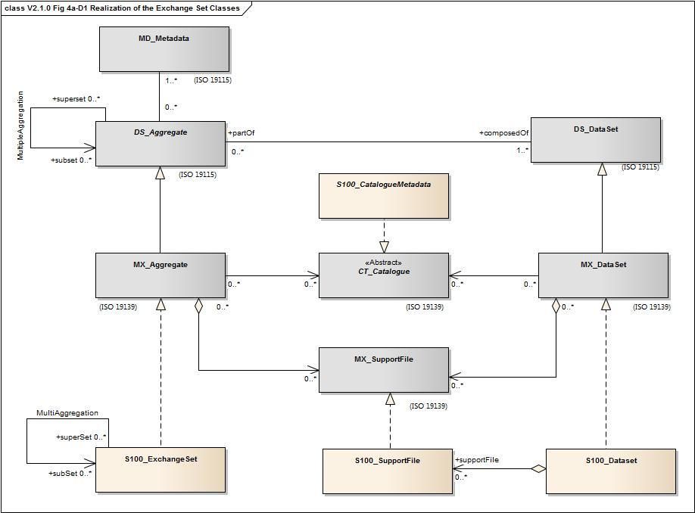
Figure 4a-D-1 Realization of the Exchange Set Classes

The S100_ExchangeCatalogue is an XML instance, which provides the information needed to exploit all the components of an exchange set. It consists of sections for the catalogues and datasets with subsections for support file metadata and a reference to classic ISO 19115 dataset metadata.
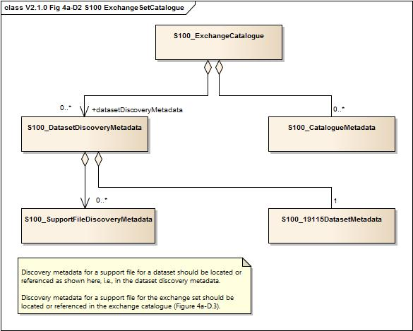
Figure 4a-D-2 – S-100 Exchange Set Catalogue
The S-100 Exchange set is a container that combines all the elements needed for the exchange of S-100 data. The exchange set may include S-100 based datasets, files, feature catalogues and portrayal catalogues as shown in figure 4a-D-3 below.
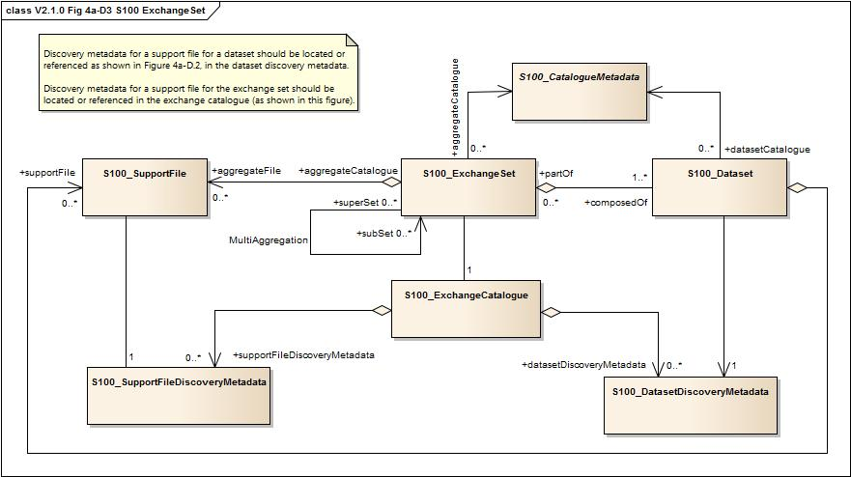

Figure 4a-D-3 – S-100 Exchange Set

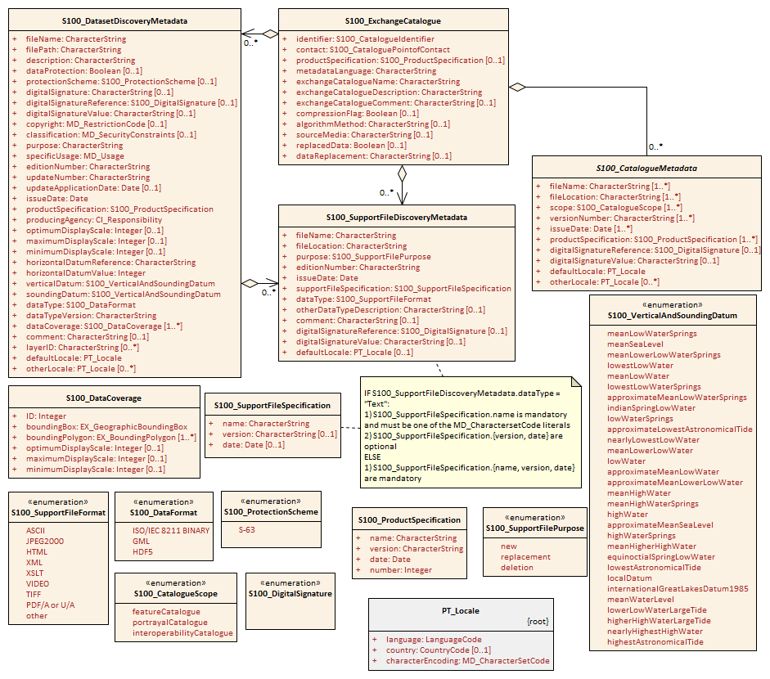
Figure 4a-D-4 S-100 Exchange Set - class details

Elements of the exchange set
S100_ExchangeSet
An S-100 Exchange Set is an aggregation of all the various elements required to support the interchange of geospatial data and metadata. The MultiAggregation association introduces the concept of using subsets which could be domain oriented, for example packaged by scale, producer, region etc.
Role Name | Name | Description | Mult | Type | Remarks
Class | S100_ExchangeSet | Aggregation of the elements comprising an exchange set for the transfer of data | - | - | -
Role | aggregateFile | Collection of support files in the exchange set | 0..* | -
Role | partOf | Collection of datasets which are part of the exchange set | 0..* | -
Role | aggregateCatalogue | Collection of catalogues | 0..* | -
Role | superSet | The master container exchange set which can contain a subSet of exchange sets
Role | subSet | Exchange set which is part of the superSet

S100_ExchangeCatalogue
Each exchange set has a single S100_ExchangeCatalogue which contains meta information for the data and support files in the exchange set.
Role Name | Name | Description | Mult | Type | Remarks
Class | S100_ExchangeCatalogue | An exchange catalogue contains the discovery metadata about the exchange datasets and support files | - | - | -
Attribute | identifier | Uniquely identifies this exchange catalogue | 1 | S100_CatalogueIdentifier
Attribute | contact | Details about the issuer of this exchange catalogue | 1 | S100_CataloguePointOfContact
Attribute | productSpecification | Details about the product specifications used for the datasets contained in the exchange catalogue | 0..1 | S100_ProductSpecification | Conditional on all the datasets using the same product specification
Attribute | metadataLanguage | Details about the Language | 1 | CharacterString
Attribute | exchangeCatalogueName | Catalogue filename | 1 | CharacterString | In S-101 it would be CATLOG.101
Attribute | exchangeCatalogueDescription | Description of what the exchange catalogue contains | 1 | CharacterString
Attribute | exchangeCatalogueComment | Any additional Information | 0..1 | CharacterString
Attribute | compressionFlag | Is the data compressed | 0..1 | Boolean | Yes or No
Attribute | algorithmMethod | Type of compression algorithm | 0..1 | CharacterString | 1. ZIP
Attribute | sourceMedia | Distribution media | 0..1 | CharacterString
Attribute | replacedData | If a data file is cancelled is it replaced by another data file | 0..1 | Boolean
Attribute | dataReplacement | Cell name | 0..1 | CharacterString

S100_CatalogueIdentifier
Role Name | Name | Description | Mult | Type | Remarks
Class | S100_CatalogueIdentifier | An exchange catalogue contains the discovery metadata about the exchange datasets and support files | - | - | -
Attribute | identifier | Uniquely identifies this exchange catalogue | 1 | CharacterString
Attribute | editionNumber | The edition number of this exchange catalogue | 1 | CharacterString
Attribute | date | Creation date of the exchange catalogue | 1 | Date

S100_CataloguePointofContact
Role Name | Name | Description | Mult | Type | Remarks
Class | S100_CataloguePointOfContact | Contact details of the issuer of this exchange catalogue | - | - | -
Attribute | organization | The organization distributing this exchange catalogue | 1 | CharacterString | This could be an individual producer, value added reseller, etc.
Attribute | phone | The phone number of the organization | 0..1 | CI_Telephone
Attribute | address | The address of the organization | 0..1 | CI_Address

S100_Dataset
Role Name | Name | Description | Mult | Type | Remarks
Class | S100_Dataset |  | - | - | -
Role | composedOf | An exchange set is composed of 0 or more datasets | 0..* | -
Role | datasetCatalogue | Catalogue which is related to this dataset | 0..* | -

S100_DatasetDiscoveryMetaData
Role Name | Name | Description | Mult | Type | Remarks
Class | S100_DatasetDiscoveryMetadata | Metadata about the individual datasets in the exchange catalogue | - | - | -
Attribute | fileName | Dataset file name | 1 | CharacterString
Attribute | filePath | Full path from the exchange set root directory | 1 | CharacterString | Path relative to the root directory of the exchange set. The location of the file after the exchange set is unpacked into directory <EXCH_ROOT> will be <EXCH_ROOT>/<filePath>/<filename>
Attribute | description | Short description giving the area or location covered by the dataset | 1 | CharacterString | For example, a harbour or port name, between two named locations etc.
Attribute | dataProtection | Indicates if the data is encrypted | 0..1 | Boolean | 0 indicates an unencrypted dataset  1 indicates an encrypted dataset
Attribute | protectionScheme | Specification or method used for data protection | 0..1 | CharacterString | For example S-63
Attribute | digitalSignature | Indicates if the data has a digital signature | 0..1 | CharacterString
Attribute | digitalSignatureReference | Digital Signature of the file | 0..1 | S100_DigitalSignature | Specifies the algorithm used to compute digitalSignatureValue  If this attribute is absent, the file is not signed.
Attribute | digitalSignatureValue | Value derived from the digital signature | 0..1 | CharacterString | The value resulting from application of digitalSignatureReference
Attribute | copyright | Indicates if the dataset is copyrighted | 0..1 | MD_LegalConstraints ->MD_RestrictionCode <copyright> (ISO 19115)
Attribute | classification | Indicates the security classification of the dataset | 0..1 | Class MD_SecurityConstraints>MD_ClassificationCode (codelist) | 1. unclassified  2. restricted  3. confidential  4. secret  5. top secret
Attribute | purpose | The purpose for which the dataset has been issued | 1 | MD_Identification>purpose  CharacterString | For example new, re-issue, new edition, update etc.
Attribute | specificUsage | The use for which the dataset is intended | 1 | MD_USAGE>specificUsage (character string)  MD_USAGE>userContactInfo (CI_Responsibility) | For example, in the case of ENCs this would be a Navigational Purpose classification
Attribute | editionNumber | The edition number of the dataset | 1 | CharacterString | When a data set is initially created, the edition number 1 is assigned to it. The edition number is increased by 1 at each new edition. Edition number remains the same for a re-issue.
Attribute | updateNumber | Update number assigned to the dataset and increased by one for each subsequent update | 0..1 | CharacterString | Update number 0 is assigned to a new dataset
Attribute | updateApplicationDate | This date is only used for the base cell files (that is new data set, re-issue and new edition), not update cell files. All updates dated on or before this date must have been applied by the producer | 0..1 | Date
Attribute | issueDate | Date on which the data was made available by the data producer | 1 | Date
Attribute | productSpecification | The product specification used to create this dataset | 1 | S100_ProductSpecification
Attribute | producingAgency | Agency responsible for producing the data | 1 | CI_Responsibility>CI_Organisation or  CI_Responsibility>CI_Individual | CI_Responsibility>CI_Organisation or  CI_Responsibility>CI_Individual
Attribute | optimumDisplayScale | The scale with which the data is optimally displayed | 0..1 | Integer | Example: A scale of 1:25000 is encoded as 25000
Attribute | maximumDisplayScale | The maximum scale with which the data is displayed | 0..1 | Integer
Attribute | minimumDisplayScale | The minimum scale with which the data is displayed | 0..1 | Integer
Attribute | horizontalDatumReference | Reference to the register from which the horizontal datum value is taken | 1 | characterString | EPSG
Attribute | horizontalDatumValue | Horizontal Datum of the entire dataset | 1 | Integer | 4326
Attribute | verticalDatum | Vertical Datum of the entire dataset | 1 | S100_VerticalAndSoundingDatum
Attribute | soundingDatum | Sounding Datum of the entire dataset | 1 | S100_VerticalAndSoundingDatum
Attribute | dataType | The encoding format of the dataset | 1 | S100_DataFormat
Attribute | otherDataTypeDescription | Encoding format other than those listed. | 0..1 | CharacterString
Attribute | dataTypeVersion | The version number of the dataType. | 1 | CharacterString
Attribute | dataCoverage | Provides information about data coverages within the dataset | 1..* | S100_DataCoverage
Attribute | comment | Any additional information | 0..1 | CharacterString
Attribute | layerID | Identifies other layers with which this dataset is intended to be used or portrayed | 0..* | CharacterString | For example, a marine protected area dataset needs an ENC dataset to portray as intended in an ECDIS
Attribute | defaultLocale | default language and character set used in the exchange catalogue | 1 | PT_Locale
Attribute | otherLocale | other languages and character sets used in the exchange catalogue | 0..* | PT_Locale

S100_DataCoverage
Role Name | Name | Description | Mult | Type | Remarks
Class | S100_DataCoverage |  | - | - | -
Attribute | ID | Uniquely identifies the coverage | 1 | Integer | -
Attribute | boundingBox | The extent of the dataset limits | 1 | EX_GeographicBoundingBox | -
Attribute | boundingPolygon | A polygon which defines the actual data limit | 1..* | EX_BoundingPolygon | -
Attribute | optimumDisplayScale | The scale with which the data is optimally displayed | 0..1 | Integer | Example: A scale of 1:25000 is encoded as 25000
Attribute | maximumDisplayScale | The maximum scale with which the data is displayed | 0..1 | Integer
Attribute | minimumDisplayScale | The minimum scale with which the data is displayed | 0..1 | Integer

S100_VerticalAndSoundingDatum
Role Name | Name | Description | Mult | Type | Remarks
Class | S100_VerticalAndSoundingDatum | Allowable vertical and sounding datums | - | - | -
Value | meanLowWaterSprings |  | - | - | -
Value | meanSeaLevel |  | - | - | -
Value | meanLowerLowWaterSprings |  | - | - | -
Value | lowestLowWater |  | - | - | -
Value | meanLowWater |  | - | - | -
Value | lowestLowWaterSprings |  | - | - | -
Value | approximateMeanLowWaterSprings |  | - | - | -
Value | indianSpringLowWater |  | - | - | -
Value | lowWaterSprings |  | - | - | -
Value | approximateLowestAstronomicalTide |  | - | - | -
Value | nearlyLowestLowWater |  | - | - | -
Value | meanLowerLowWater |  | - | - | -
Value | lowWater |  | - | - | -
Value | approximateMeanLowWater |  | - | - | -
Value | approximateMeanLowerLowWater |  | - | - | -
Value | meanHighWater |  | - | - | -
Value | meanHighWaterSprings |  | - | - | -
Value | highWater |  | - | - | -
Value | approximateMeanSeaLevel |  | - | - | -
Value | highWaterSprings |  | - | - | -
Value | meanHigherHighWater |  | - | - | -
Value | equinoctialSpringLowWater |  | - | - | -
Value | lowestAstronomicalTide |  | - | - | -
Value | localDatum |  | - | - | -
Value | internationalGreatLakesDatum1985 |  | - | - | -
Value | meanWaterLevel |  | - | - | -
Value | lowerLowWaterLargeTide |  | - | - | -
Value | higherHighWaterLargeTide |  | - | - | -
Value | nearlyHighestHighWater |  | - | - | -
Value | highestAstronomicalTide |  | - | - | (HAT)

S100_DataFormat
Role Name | Name | Description | Mult | Type | Remarks
Class | S100_DataFormat | The encoding format | - | - | -
Value | ISO/IEC 8211 |  | - | - | -
Value | GML |  | - | - | -
Value | HDF5
Value | Other |  | - | - | -

S100_ProductSpecification
Role Name | Name | Description | Mult | Type | Remarks
Class | S100_ProductSpecification | The Product Specification contains the information needed to build the specified product | - | - | -
Attribute | name | The name of the product specification used to create the datasets | 1 | CharacterString
Attribute | version | The version number of the product specification | 1 | CharacterString
Attribute | date | The version date of the product specification | 1 | Date
Attribute | number | The unique number identifying the product specification | 1 | Integer

S100_SupportFile
Role Name | Name | Description | Mult | Type | Remarks
Class | S100_SupportFile |  | - | - | -
Role | aggregateFile | Collection of support files | 0..* | -
Role | supportFile | File which has information about a dataset | 0..* | -

S100_SupportFileDiscoveryMetadata
Role Name | Name | Description | Mult | Type | Remarks
Class | S100_SupportFiletDiscoveryMetadata | Metadata about the individual support files in the exchange catalogue | - | - | -
Attribute | fileName | Name of the support file | 1 | CharacterString
Attribute | fileLocation | Full location from the exchange set root directory | 1 | CharacterString | Path relative to the root directory of the exchange set. The location of the file after the exchange set is unpacked into directory <EXCH_ROOT> will be <EXCH_ROOT>/<filePath>/<filename>
Attribute | purpose | The purpose for which the dataset has been issued | 1 | S100_SupportFilePurpose | For example new, re-issue, new edition, update etc.
Attribute | editionNumber | The edition number of the dataset | 1 | CharacterString | When a data set is initially created, the edition number 1 is assigned to it. The edition number is increased by 1 at each new edition. Edition number remains the same for a re-issue
Attribute | issueDate | Date on which the data was made available by the data producer | 1 | Date
Attribute | productSpecification | The product specification used to create this file | 1 | S100_ProductSpecification
Attribute | dataType | The format of the support file | 1 | S100_SupportFileFormat
Attribute | otherDataTypeDescription | Support file format other than those listed | 0..1 | CharacterString
Attribute | dataTypeVersion | The version number of the dataType. | 1 | CharacterString
Attribute | comment |  | 0..1 | CharacterString
Attribute | digitalSignatureReference | Digital Signature of the file | 0..1 | CharacterString | Reference to the appropriate digital signature algorithm
Attribute | digitalSignatureValue | Value derived from the digital signature | 0..1 | CharacterString
Attribute | defaultLocale | default language and character set used in the exchange catalogue | 0..1 | PT_Locale | A support file is expected to use only one locale, because other files can be created for other languages

S100_SupportFileFormat
Role Name | Name | Description | Mult | Type | Remarks
Class | S100_SupportFormat | The format used in the support file | - | - | -
Value | ASCII |  | - | -
Value | JPEG2000 |  | - | -
Value | HTML |  | - | -
Value | XML |  | - | -
Value | XSLT |  | - | -
Value | VIDEO |  | - | -
Value | TIFF
Value | PDF/A or UA |  |  |  | Product Specification developers should take careful consideration in using PDF as a support file format. It is recommended that PDF never be used in products that will be used on a navigation system as it may impair night vision
Value | Other |  | - | -

S100_SupportFilePurpose
Role Name | Name | Description | Mult | Type | Remarks
Class | S100_SupportFilePurpose | The reason for inclusion of the support file in this exchange set | - | - | -
Value | new | A file which is new | - | - | Signifies a new file
Value | replacement | A file which replaces an existing file | - | - | Signifies a replacement for a file of the same name
Value | deletion | Deletes an existing file | - | - | Signifies deletion of a file of that name

S100_CatalogueMetadata
Role Name | Name | Description | Mult | Type | Remarks
Class | S100_Catalogue |  | - | - | -
Attribute | filename | The name for the catalogue | 1..* | CharacterString
Attribute | fileLocation | Full location from the exchange set root director | 1..* | CharacterString | Path relative to the root directory of the exchange set. The location of the file after the exchange set is unpacked into directory <EXCH_ROOT> will be <EXCH_ROOT>/<filePath>/<filename>
Attribute | scope | Subject domain of the catalogue | 1..* | S100_CatalogueScope
Attribute | versionNumber | The version number of the product specification | 1..* | CharacterString
Attribute | issueDate | The version date of the product specification | 1..* | Date
Attribute | productSpecification | The product specification used to create this file | 1..* | S100_ProductSpecification
Attribute | digitalSignatureReference | Digital Signature of the file | 0..1 | S100_DigitalSignature | Reference to the appropriate digital signature algorithm
Attribute | digitalSignatureValue | Value derived from the digital signature | 0..1 | CharacterString
Attribute | defaultLocale | default language and character set used in the exchange catalogue | 1 | PT_Locale
Attribute | otherLocale | other languages and character sets used in the exchange catalogue | 0..* | PT_Locale

S100_CatalogueScope
Role Name | Name | Description | Mult | Type | Remarks
Class | S100_CatalogueScope |  | - | - | -
Value | featureCatalogue
Value | portrayalCatalogue
value | interoperabilityCatalogue

S100_SV_ServiceIdentification

Role Name | Name | Description | Mult | Type | Remarks
Class | S100_SV_ServiceIdentitification | Identification of capabilities which a service provider makes available to a service user through a set of interfaces which define a behavior | - | - | Realization of SV_ServiceIdentification (ISO 19115-1) and thereby a specialization of MD_Identification
Attribute | serviceType | a service type name | 1 | Class GenericName | GenericName is an abstract class for all names in a NameSpace. Each instance of a GenericName is either a LocalName or a ScopedName. A LocalName references a local object directly accessible from the NameSpace. A ScopedName is a composite of a LocalName for locating another NameSpace and a GenericName valid in the NameSpace. (ISO 19103).  In short: A name that is defined in a namespace.
Attribute | serviceTypeVersion | The version of the service, supports searching based on the version of serviceType. | 0..* | CharacterString
Attribute | accessProperties | Information about the availability of the service, including fees, planned available date and time, ordering instructions, turnaround | 0..1 | MD_StandardOrderprocess | ISO 19115-1 B.11.5
Attribute | operatedDataset | Provides a reference to the resource on which the service operates | 0..* | CI_Citation | For any single resource referenced, only one of operatedDataset or operatesOn is allowed to be documented (not both for the same resource).
Attribute | profile | profile to which the service adheres | 0..* | CI_Citation | profile of the standard cited in serviceStandard
Attribute | serviceStandard | standard to which the service adheres | 0..* | CI_Citation | E.g., citation for OGC WFS, WMS, etc.
Role | operatesOn |  | 0..* | MD_DataIdentification | For any single resource referenced, only one of operatedDataset or operatesOn is allowed to be documented (not both for the same resource).
(Inherited properties) | (Inherited from MD_Identification.)

Page intentionally left blank

Conformance class 1 as described at Section 2 Conformance and Appendix B.3 Example of a profile with specialisations (ISO 19106:2004).
A profile of a single base standard can include a subset, which is equivalent to the entire base standard. That is, a subset can equal the whole (19106:2005, p15).
This conforms to the rules included at Annex C.6 (ISO 19115:2005).
Reference to values documented in the S-100 Metadata encoding guide. They do not appear in the ISO 19115:2003 codelists.
Enumeration: A fixed list of valid identifiers of named literal values. Attributes of an enumerated type may only take values from this list (source: ISO 19136:__, Geographic information — Geography Markup Language (GML)).

